Task 4 :
Organizing your work: Labels, Components, Versions and Templates - 2 hour(s)
- Using Issue Labels and Priorities (list views) to Organize Work in Jira
- Structuring Work with Components in Jira Projects
- Planning and Releasing with Versions in Jira
- Creating Templates and Reusable Tasks for Efficiency

Using Issue Labels and Priorities to Organize Work in Jira
Organising is needed to solve many issues when project grows. Jira provides labels and priority fields to categorize, filter, and manage work effectively.
Issue Labels
- Custom tags that categorize issues (e.g., frontend, bug, urgent).
- Hashtags for isses and helps to group related issues.
- Enable filtering, searching, and grouping issues in boards and list views.
- Help teams quickly identify related work across projects.
- One issue can have multiple labels and same label can span many issues.
Hands on :
- Open the issue you want to tag.
- Locate the Labels field (usually on the right panel or under details).
- Click the Labels field, type a new label name or select an existing one.
- Press Enter to save the label.
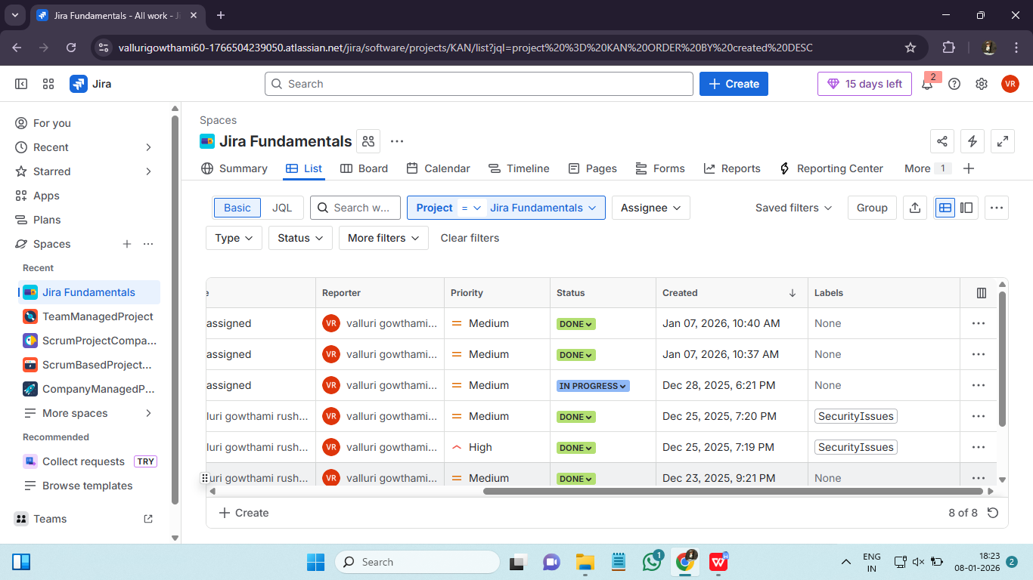

Issue Priorities
- Indicate the importance or urgency of an issue (e.g., Highest, High, Medium, Low, Lowest).
- Guide teams on what to address first.
- Can be used in reports and dashboards to focus on critical tasks.
- It shows business urgency.
Hands on :
- Open the issue you want to prioritize.
- Locate the Priority field.
- Click the dropdown and select a priority (e.g., Highest, High, Medium, Low, Lowest).
- Changes are saved automatically.
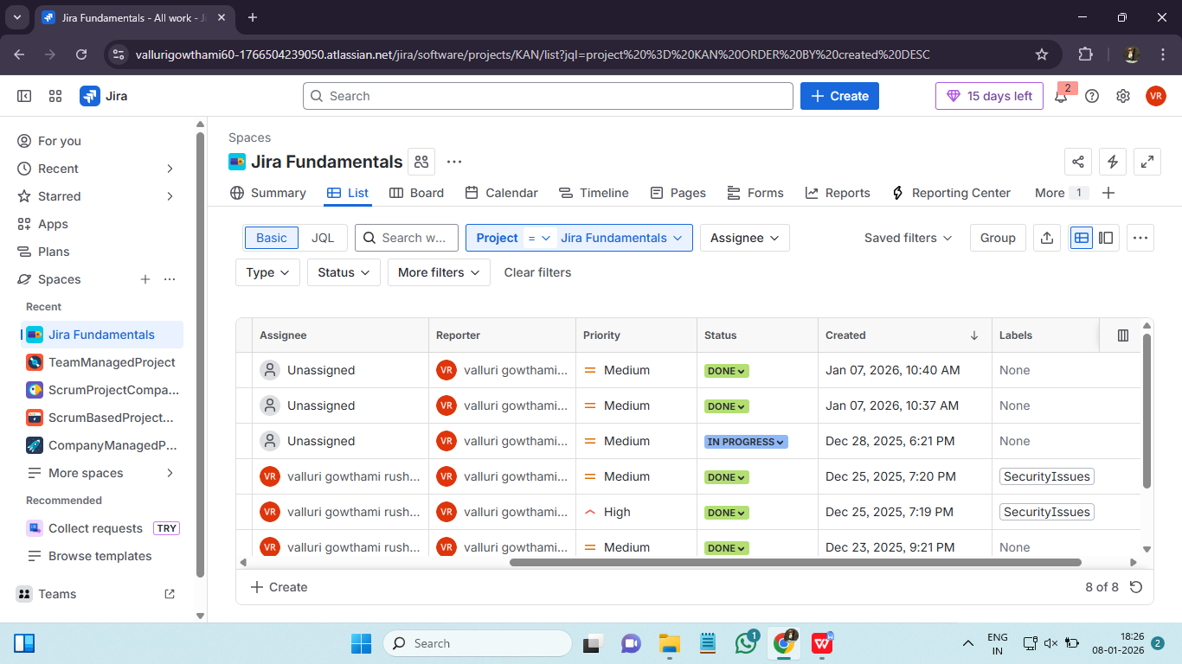

List Views
- Jira allows viewing issues in list or table format, showing labels, priorities, assignees, and statuses.
- Useful for bulk updates, sorting, and filtering issues.
- It shows issues in table format like spreadsheet and we can customize columns.
- It is best for planning & execution.
- List views + filters = control
Hands on :
- Go to your Jira project.
- Click Issues or Filters → View All Issues.
- Select List view (table layout) from the top-right corner of the board or search results.
- Use columns to display important fields such as Labels, Priority, Assignee, Status.
- Apply filters or sorting to focus on specific labels, priorities, or issue types.

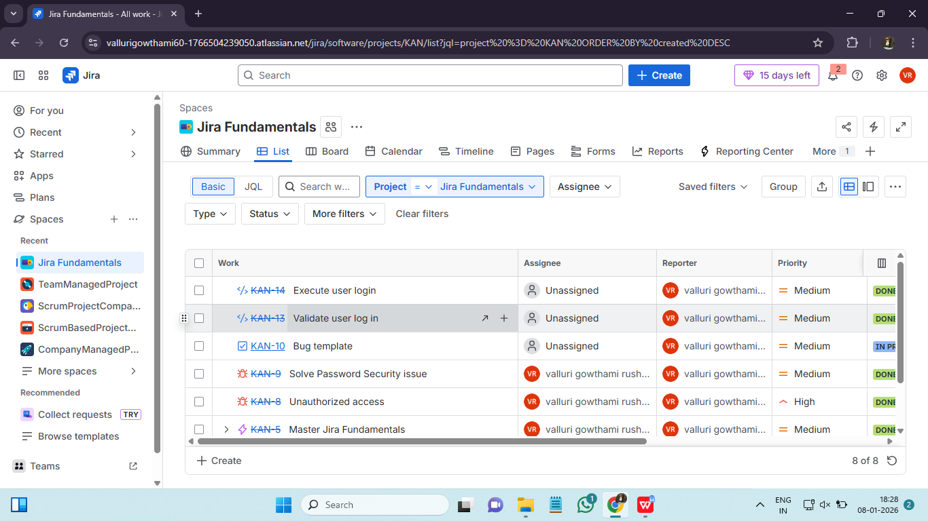

Structuring Work with Components in Jira Projects ::
Components in Jira are a way to divide a project into smaller, manageable parts based on functionality, team, module, or feature area.
Key Features of Components
- Represent sub-sections of a project (e.g., Frontend, Backend, API, UI/UX).
- Can be assigned default leads who are responsible for issues in that component.
- Help categorize issues for reporting, filtering, and tracking.
- Support automation (e.g., automatically assign issues to component leads).
Hands on :
- Go to your Jira project.
- Click Project Settings (usually in the left sidebar).
- Select Components from the menu.
- Click Create Component.
- Fill in the fields:
  - Name – e.g., Frontend, Backend, Payments
  - Description – optional, explain the purpose of the component
  - Component Lead – assign a team member responsible for this component
  - Default Assignee – choose who issues will be automatically assigned to (optional)
- Click Add to save the component.

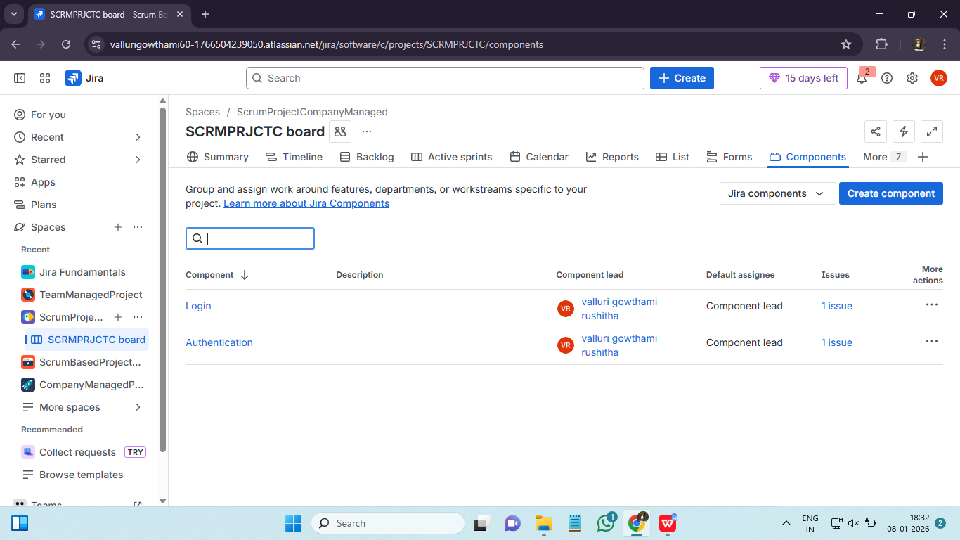

Planning and Releasing with Versions in Jira ::
Versions (also called Releases) in Jira are used to plan, track, and deliver work tied to a specific release or milestone. They help teams organize issues, manage timelines, and communicate release progress. With Versions work is grouped by release, progress is visible and releases are predictable. Many epics/ stories are part of version.
Version states :
- Unreleased : Planned / in progress.
- Released : Delivered to users.
- Archived : Old, no longer relevant.
Releases strategies are :
- Feature Release : Version per major feature
- Time based Release : Monthly / quaterly releases
- Continous delivery : Frequent small releases

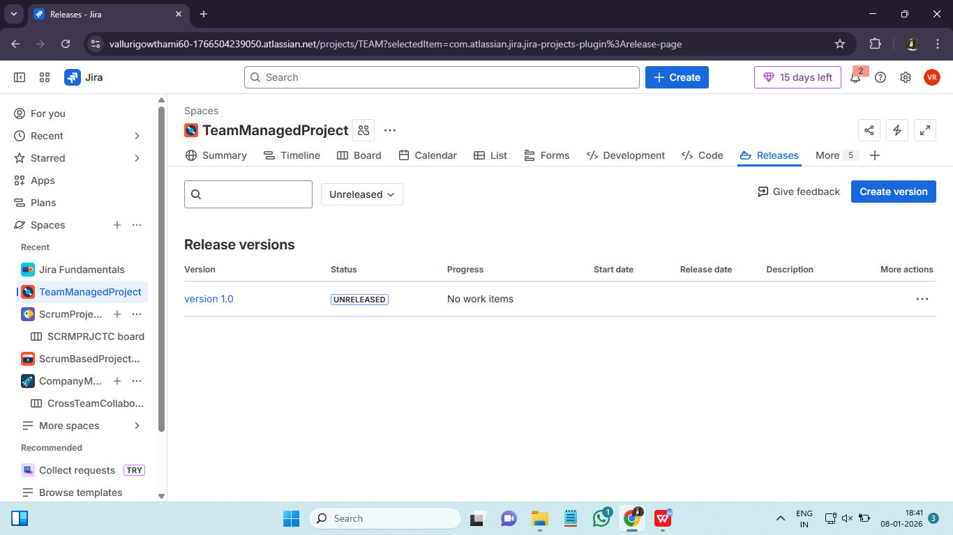

Creating Templates and Reusable Tasks for Efficiency in Jira ::
Jira allows teams to save time and standardize work by using templates and reusable tasks for recurring processes.
Using Issue Templates (Reusable Tasks)
- Pre-fill fields like summary, description, components, labels, assignee, and priority.
- Ideal for recurring tasks or standard processes (e.g., onboarding, bug triage).
Creating a Template
- Open the issue you want as a template.
- Fill in all necessary fields.
- Save as a template (if using a plugin) or keep as a master issue.
- Copy or clone the template for new work.
Cloning Issues
- Open an issue, select More → Clone.
- Include subtasks, attachments, and links if needed.
- Modify the cloned issue and save.

